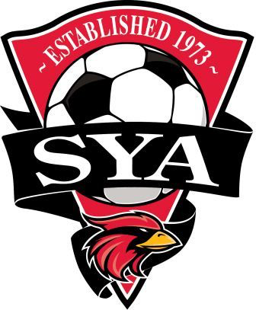
SYA Coaches Travel Reimbursement Policy
- All SYA Travel Coaches will be responsible for their respective travel expenses within the boundaries of the respective league of the team. (ODSL/ NCSL /CCL) This includes all league games. Local tournaments within the boundaries of the leagues are the coaches’ responsibility. The exceptions are CCL games with the southern CCL teams (FC Richmond, Virginia Legacy, Beach FC, VA Rush, New River, CVU (Lynchburg), SVU (Harrisonburg), SOCA, and VBR/ Roanoke as well as all U15-U19 CCL Showcase games played at River City) and Region I games outside of the DC Metro area. In these cases the ‘tournament mileage’ listed below will apply.

- All SYA teams will be responsible for the head coach’s travel expenses (or the assistant coach’s if head coach is not travelling) for soccer tournaments outside the area of league play.

- Teams will pay for the coach’s hotel, and it is expected that coaches will stay in the same hotel as the team. Rooms are to be standard rooms. (Payment by the team for additional persons in the room is not expected and any incidentals such as movie rental or mini bar purchases at the time of check out are the coach’s responsibility.)

- Meals. The coach will be provided $30 Per Diem for out of area tournaments.

- Mileage. If a tournament is less than 350 miles round-trip from Centreville, the coach is expected to travel by car. Mileage will be reimbursed at 40 cents per mile.
If the distance to a tournament is greater than 350 miles round-trip and the team has elected to drive, it maybe beneficial to the team to have the coach rent a car and have the pay for the rental and gas rather than to pay the 40 cents per mile fee. (This is at the discretion of each team.) If appropriate coaches may carpool with parents at no cost to the team.

- Tolls. Receipts are to be provided by the coach to the team for reimbursement.

- Flights. For teams traveling by plane to tournaments, the head coach is to be provided a round trip ticket (economy class). Coaches required to fly to tournament events will be provided a rental vehicle by the team. This vehicle may be used to transport players to and from the airport and fields.

- If a coach has two teams playing in the same tournament it is expected the teams split the coach’s travel expenses. This should be coordinated ahead of time by team managers.

