Sponsor Logo | Sponsor
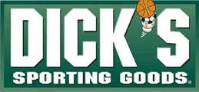 | Dick's Sporting Goods
 | Giant Food
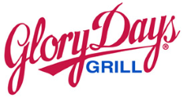 | Glory Days Grill
 | League Breeze
 | Monster Mini Golf
 | Moxie Pest Control
 | Olson Photography
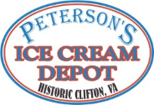 | Peterson's Ice Cream Depot
 | Wegmans

