Sponsor Logo | Sponsor | Team(s)
 | Accenture | Majors-Neely,  CP-Coons
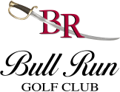 | Raspberry Falls -  Bull Run Golf Club | CP-Beal,  TB-Lender
 | Cheron Orthodontics | AAA-Bowman,  Majors Softball-O'Brien
 | Columbia Pike  Animal Hospital &  Emergency Center | TB-Shuman
 | Dick's Sporting Goods | Majors-Ewell,  CP-Costanzo,  TB-Crigler,  Seniors Softball-Novack
 | G&C Tire & Auto | CP-Witte
 | Giant Food | Majors-Gambone,  AAA-Zirk,  AA-Leiser,  MP-Martinez,  TB-Spaulding,  AAA Softball-Carey,  AAA Softball-Luther,  AA Softball-McArthur,  AA Softball-Lalli,  Rookies Softball-Mann
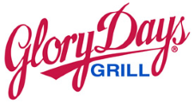 | Glory Days Grill | AAA-Lindahl,  CP-Lilburn,  TB-Herbek
 | Great American  Restaurants | TB-Palacios
 | Home Works Painting | AA-Katounas
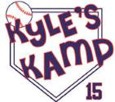 | Kyle's Kamp | AA-McNerney
 | League Breeze | Majors-Nitz,  AAA-Weber
 | Lorton Stone, LLC | MP-Sartori
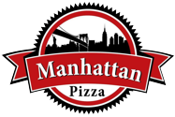 | Manhattan Pizza | CP-Hutzler
 | Modell's | AAA-Hill,  MP-Poppert,  CP-Lalli
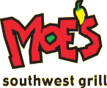 | Moe's Southwest Grill | CP-Hayduk
 | Monster Mini Golf | CP-Jimenez
 | Moxie Pest Control | MP-Testani
 | Raspberry Falls -  Old Hickory Golf Club | TB-Goldberg,  TB-Coons
 | Olson Photography | MP-Sajdak,  CP-Morrell
 | Peterson's Ice Cream Depot | AAA-Lutes,  AA-Morgan,  CP-Blount,  TB-Sweet
 | Pev's Paintball | AAA-Furr,  AA-Cho
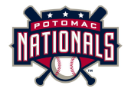 | Potomac Nationals | MP-Dharia,  TB-Poppert
 | Pure Performance | AA-Beal
 | Sheetz | MP-Cable,  TB-Frizzi
 | Smiles for Centreville -  Drs. Hutchison, Gorman,  Mooney & Grossman | MP-Pilon
 | Supervisor Kathy Smith | Majors-Hull
 | Supervisor Pat Herrity | Majors-Rosenberg
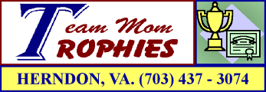 | Team Mom Trophies | Majors-Sanders
 | Thompson Greenspon | TB-Penley
 | Town & Country  Animal Hospital | AAA-Chase
 | Raspberry Falls -  Virginia Golf Center | CP-Vickers,  TB-Gallivan
 | Wegmans | CP-Danisek,  TB-Sartori

